Bibliography for US Presidents - Don Gadberry – Spring 2026 updated: 1/21/26
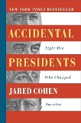  Link | Excellent Book about the  unexpected losses of Presidents |  | 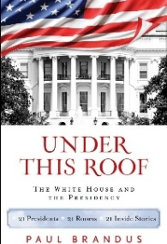  Link | 21 Presidents 21 Rooms,  21 Stories.  Good book |  | 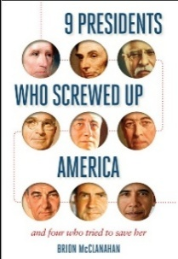  Link | In depth study about 9 Presidents and how their mistakes shaped U.S.
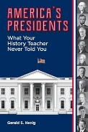  Link | Great stories.  Story form and easy read. |  | 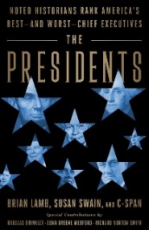  Link | C-SPAN has surveyed leading historians on the best and worst |  | 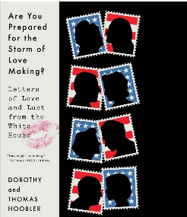  Link | Love lives and letters of several Presidents.
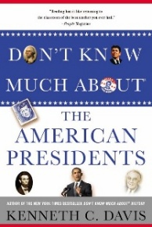  Link | One more of the series pertaining to little known facts. Neat Read. |  | 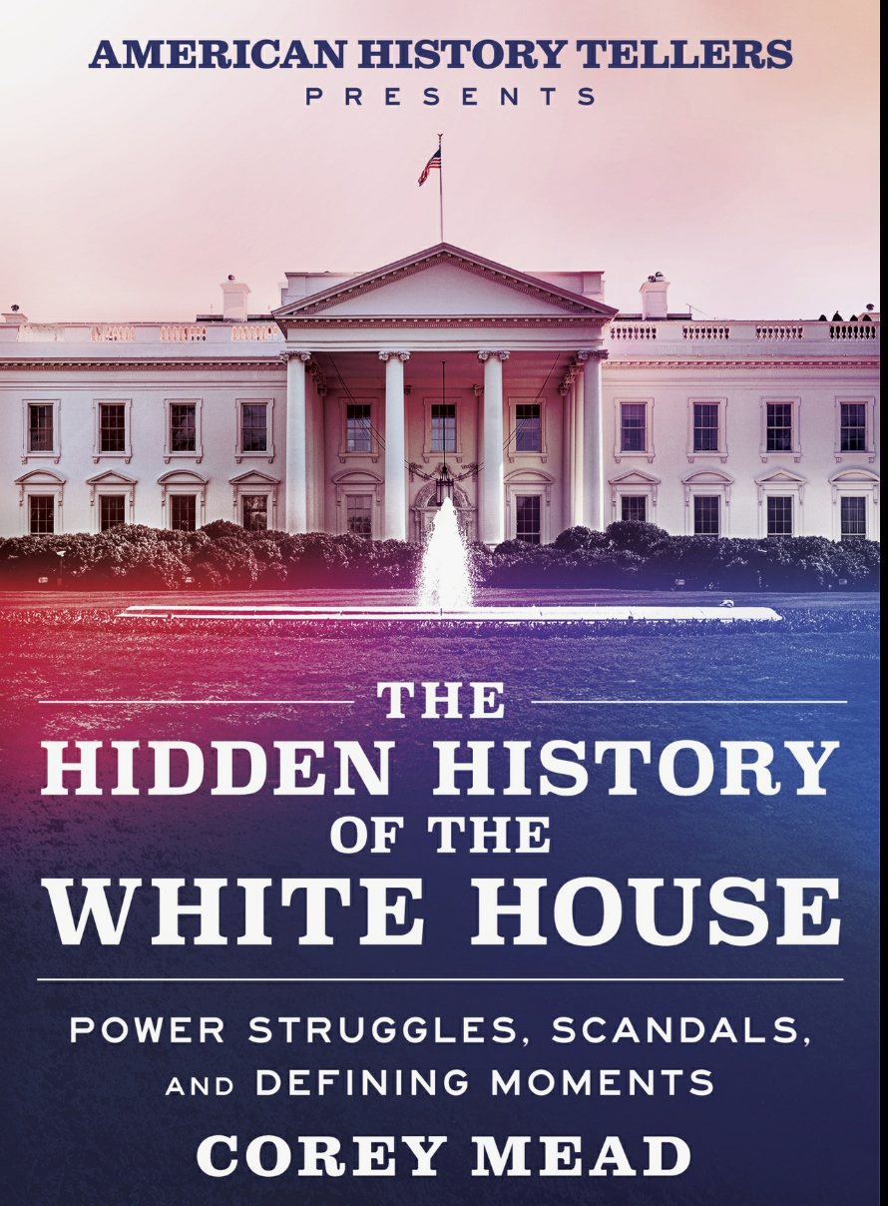  Link | Lots of stories about the building and the occupants |  | 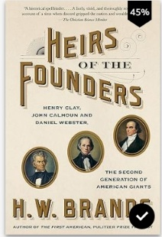  Link | Great History about Clay, Webster, and Calhoun
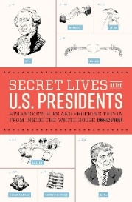  Link | Expansion of the little known facts about the Presidents. Story form – easy read. |  | 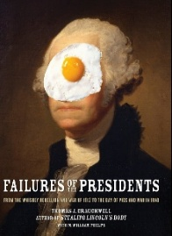  Link | Generalizes and categorizes facts |  | 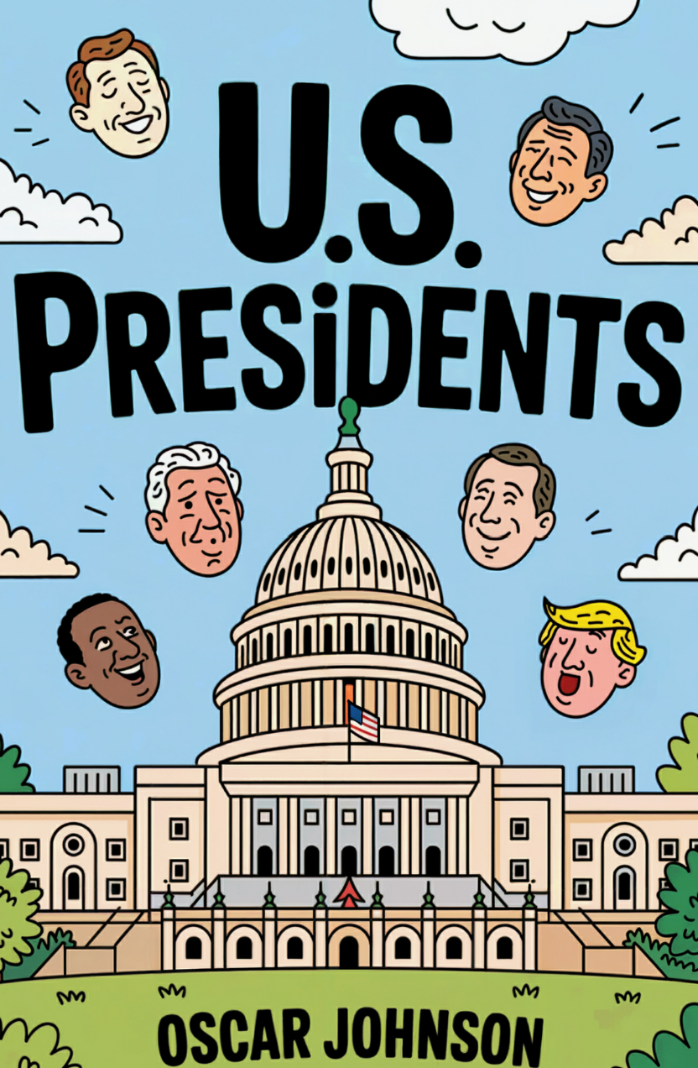  Link | An Overview of the Presidents through the US political eras Simple, but worthy
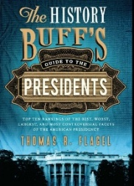  Link | Top Ten Presidential Pastimes  Top Ten Most Controversial Elections |  | 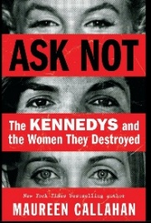  Link | An un-annotated “expose” Kennedy men treating wives |  | 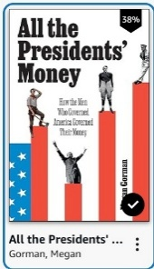  Link | Great stories about Money
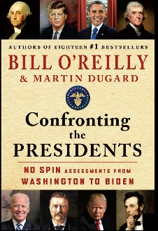  Link | Lots of short stories about each Prez |  | 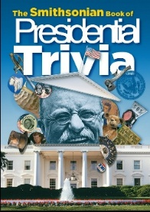  Link | Very good facts |  | 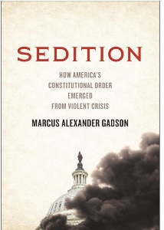  Link | Excellent  How States formed their Constitutions  Especially  1868  So. Carolina

